Automating Email Responses with Seq2Seq Learning

Regis University

Beth Birhanu

**Introduction**

In today's professional world, email stands as a critical mode of communication. Yet, the task of crafting responses remains time-consuming, often hindering productivity. This project proposes a solution through the automation of email responses, utilizing Sequence to Sequence (Seq2Seq) learning. By harnessing advanced machine learning algorithms and the comprehensive Enron email dataset, this initiative aims to revolutionize the way email responses are generated, enhancing efficiency and productivity in professional settings.

**Background and Motivation**

The motivation behind this project comes from the noticeable inefficiency in manual email communication. The growing demand for intelligent automation in text generation, coupled with the capabilities of Seq2Seq learning models, sets the stage for developing a system capable of automating email responses. This approach not only promises to streamline communication but also significantly improves overall productivity.

**About the Dataset**

The foundation of this project is the [Enron email dataset](https://www.cs.cmu.edu/~enron/), containing half a million emails from approximately 150 users. This dataset, emerging from investigations by the Federal Energy Regulatory Commission, offers a diverse range of real-world communication data, making it an ideal corpus for training an email response model.

**Data Preprocessing and Exploration**

* Exploratory Data Analysis (EDA)

Initial analysis focused on understanding the distribution of email lengths, metadata attributes, and keyword frequencies. This analysis informed subsequent preprocessing steps and model training strategies.

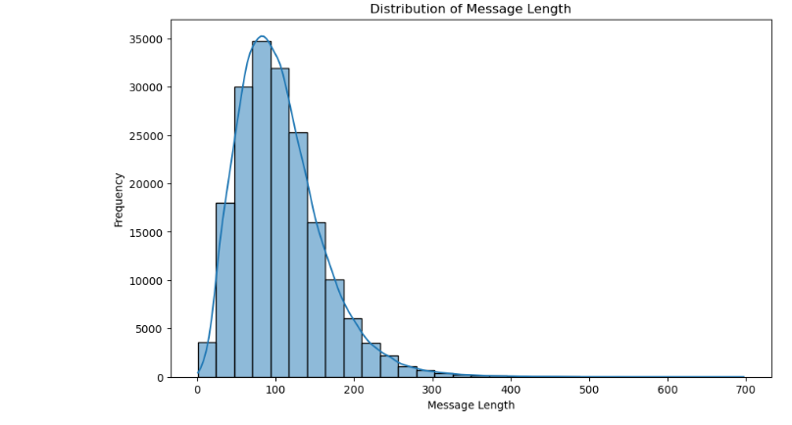

**Figures**

1. Distribution of Email Lengths: A histogram showcasing the variability in email lengths within the dataset.

2. Keyword Frequencies: A bar chart displaying the most common keywords or topics across the dataset, highlighting the prevalence of terms related to business activities such as "meeting," "project," and "deadline."

3. Top 10 senders

* **Data Preprocessing**

Data preprocessing is a fundamental stage in any machine learning workflow, and this project dedicated considerable effort to ensuring the Enron email dataset was optimally prepared for the Seq2Seq model. This section elaborates on the involved process of transforming raw email data into a structured format conducive to machine learning analysis, highlighting the meticulous strategies employed to ensure data quality and model performance.

**Text Cleaning and Normalization**: The initial step involved extensive cleaning of the dataset to remove any extraneous information that could impede the model's learning process. This included stripping out HTML tags, URLs, punctuation, and stop words, which are common in raw email texts but irrelevant for understanding the essence of the messages. Normalization processes were also applied to standardize the text, such as converting all characters to lowercase to reduce the complexity of the dataset.

**Tokenization**: Following cleaning, the text was tokenized, breaking it down into individual words or tokens. This process is critical for machine learning models to analyze and generate text data. By tokenizing the emails, the project could transform continuous text data into discrete units, enabling the Seq2Seq model to learn patterns and structures in email communications more effectively.

**Managing Email Length Variability**: The Enron dataset, with its real-world origins, exhibited significant variability in email lengths. To address this, the project employed truncation and padding techniques. Longer emails were truncated to a predetermined optimal sequence length, ensuring the model focused on the most relevant content without being overwhelmed by excessive information. Conversely, shorter emails were padded to meet this optimal length, maintaining consistency across the dataset and allowing the model to process all emails effectively.

**Sequence Pairing**: An essential part of preparing the dataset for the Seq2Seq model involved pairing input sequences (email inquiries) with corresponding target output sequences (appropriate responses). This step was vital for the model to learn the mapping between the given email content and the desired automated responses. The careful pairing of sequences ensured that the model training was grounded in realistic and practical email communication scenarios.

**Optimization for Model Training**: The preprocessing steps were strategically designed to optimize the dataset for the Seq2Seq model's learning process. By ensuring data quality and consistency, the project set the stage for efficient and effective model training. The prepared dataset facilitated smoother model convergence and enhanced the ability of the model to generate coherent and contextually relevant email responses.

**Model Architecture and Training**

* **Choosing the Model Architecture**

One of the project's most significant challenges was the absence of replied-to emails in the dataset, complicating the model's ability to learn from direct reply pairs. This obstacle was eliminated by the strategic selection of a Seq2Seq model augmented with LSTM units. The LSTM architecture's proficiency in capturing long-range textual dependencies made it an ideal choice for this application, enabling the model to generate responses that are both coherent and contextually appropriate despite the dataset's limitations.

* **Model Training**

The training process was significantly enhanced by using Google Colab's GPU resources, employing the teacher forcing technique, and utilizing TensorFlow and Keras libraries for an efficient and effective training cycle.

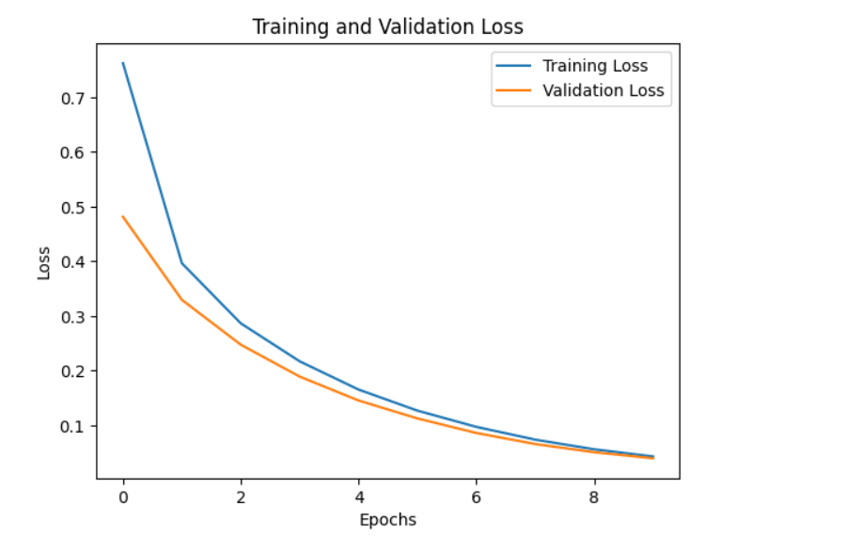

Figure 3. Training and Validation Loss Graph: A plot illustrating the decrease in training loss **Results and Analysis**

The model demonstrated impressive results, with a marked decrease in validation loss, 70% sequence accuracy, and a BLEU score of 0.95. These outcomes underscore the model's ability to generate coherent, contextually relevant responses, affirming the potential of Seq2Seq models in the domain of email response automation.

**Discussion: Limitations and Future Directions**

Despite the promising results, the project acknowledges limitations in the model's generalization capabilities. Future work could focus on incorporating attention mechanisms, exploring transformer models, and investigating unsupervised learning techniques to further refine the model's accuracy and relevance.

**Conclusion**

This project represents a significant step forward in automating email communication. Through careful dataset preparation, strategic model selection, and optimized training processes, the developed Seq2Seq model has shown promising capabilities in automating email responses, offering a glimpse into the future of efficient professional communication. The journey ahead includes exploring advanced modeling techniques and collaborative efforts to enhance the model's performance further.

**Resources**

*seq2seq model in Machine Learning*. (2018, December 5). GeeksforGeeks. <https://www.geeksforgeeks.org/seq2seq-model-in-machine-learning/>

*A ten-minute introduction to sequence-to-sequence learning in Keras*. (2017). Keras.io. https://blog.keras.io/a-ten-minute-introduction-to-sequence-to-sequence-learning-in-keras.html

‌Takezawa, A. (2021, March 8). *How to implement Seq2Seq LSTM Model in Keras #ShortcutNLP*. Medium. https://towardsdatascience.com/how-to-implement-seq2seq-lstm-model-in-keras-shortcutnlp-6f355f3e5639

‌Otten, N. V. (2023, September 28). *Sequence-to-Sequence Architecture Made Easy & How To Tutorial In Python*. Spot Intelligence. https://spotintelligence.com/2023/09/28/sequence-to-sequence/

‌*Enron Email Dataset*. (2011). Cmu.edu. https://www.cs.cmu.edu/~enron/

‌*Model Selection Techniques: How To Select A Suitable Machine Learning Model?* (n.d.). Censius.ai. https://censius.ai/blogs/machine-learning-model-selection-techniques

‌*How to Implement Seq2seq Model | cnvrg.io*. (2021, November 17). https://cnvrg.io/seq2seq-model/

Aboze, B. J. (2023, August 1). *Top Model Selection Techniques in Machine Learning Projects*. Deepchecks. https://deepchecks.com/model-selection-techniques-in-ml-projects/

‌

‌